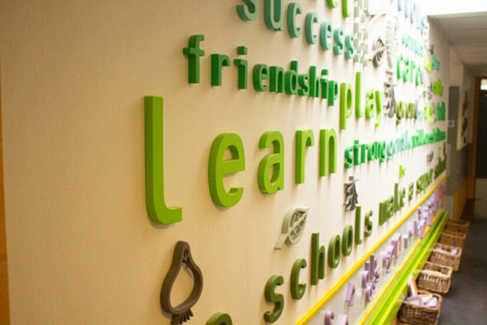
Curriculum Statement
The curriculum is designed to provide for all students, in a safe and secure environment conducive to learning. The aims and underlying principles of the Curriculum are to give children opportunities:
- to experience a broad and balanced education which encourages pupils to fulfil their potential in the many different areas relevant to their personal abilities, skills and interests
- to promote a positive attitude towards learning, so that children enjoy coming to school, and acquire a solid basis for lifelong learning
- to teach children the basic skills of literacy, numeracy & PSHE to develop co-operative and interpersonal skills
- to acquire and develop knowledge, understanding & skills that are necessary for everyday life
- to participate as effective citizens in a multi-ethnic society
- to enable children to be creative and to develop their own thinking and interests
- to develop for themselves an active and healthy lifestyle
- to appreciate and value the contribution made by all ethnic groups in our multi-cultural society
- to fulfil all the requirements of the National Curriculum and the Locally Agreed Syllabus for Religious Education
- to acquire the study skills necessary to realise their learning potential
- to teach children to have an awareness of their own spiritual development, and to distinguish right from wrong to enable children to be positive citizens
- to help children understand the importance of truth and fairness, so that they grow up committed to equal opportunities for all
- to enable children to have respect for themselves and high self-esteem, and to live and work cooperatively with others
- to progress with confidence to the next stage of their life and education through a process which encourages them to engage in lifelong learning beyond Green Park.

Class groups identify with one of three main Teaching / Learning Styles to help match the unique learning needs of pupils:
Sensory Learners | Are at the very early stages of development and learn through exploration and noticing differences within their environment
Focused Learners | Generally learn through functional activities related to their environment, age and experiences based on the underlying features of the Early Years Foundation Stage.
Structured Learners | Often learn through both sensory and or focused approaches but the key here is a structure that outlines a specific schedule as well as strategies in place that will help Structured Learners to recognise and accept changes to their routines.

All learners are unique, but at Green Park school we recognise a cohort of learners who need particularly creative strategies to increase their level of engagement. We positively identify this group as ‘Unique Learners’ and training has been provided to offer specific strategies to increase levels of engagement. These strategies may be used for other learners who are likely to gain interest and make progress.
