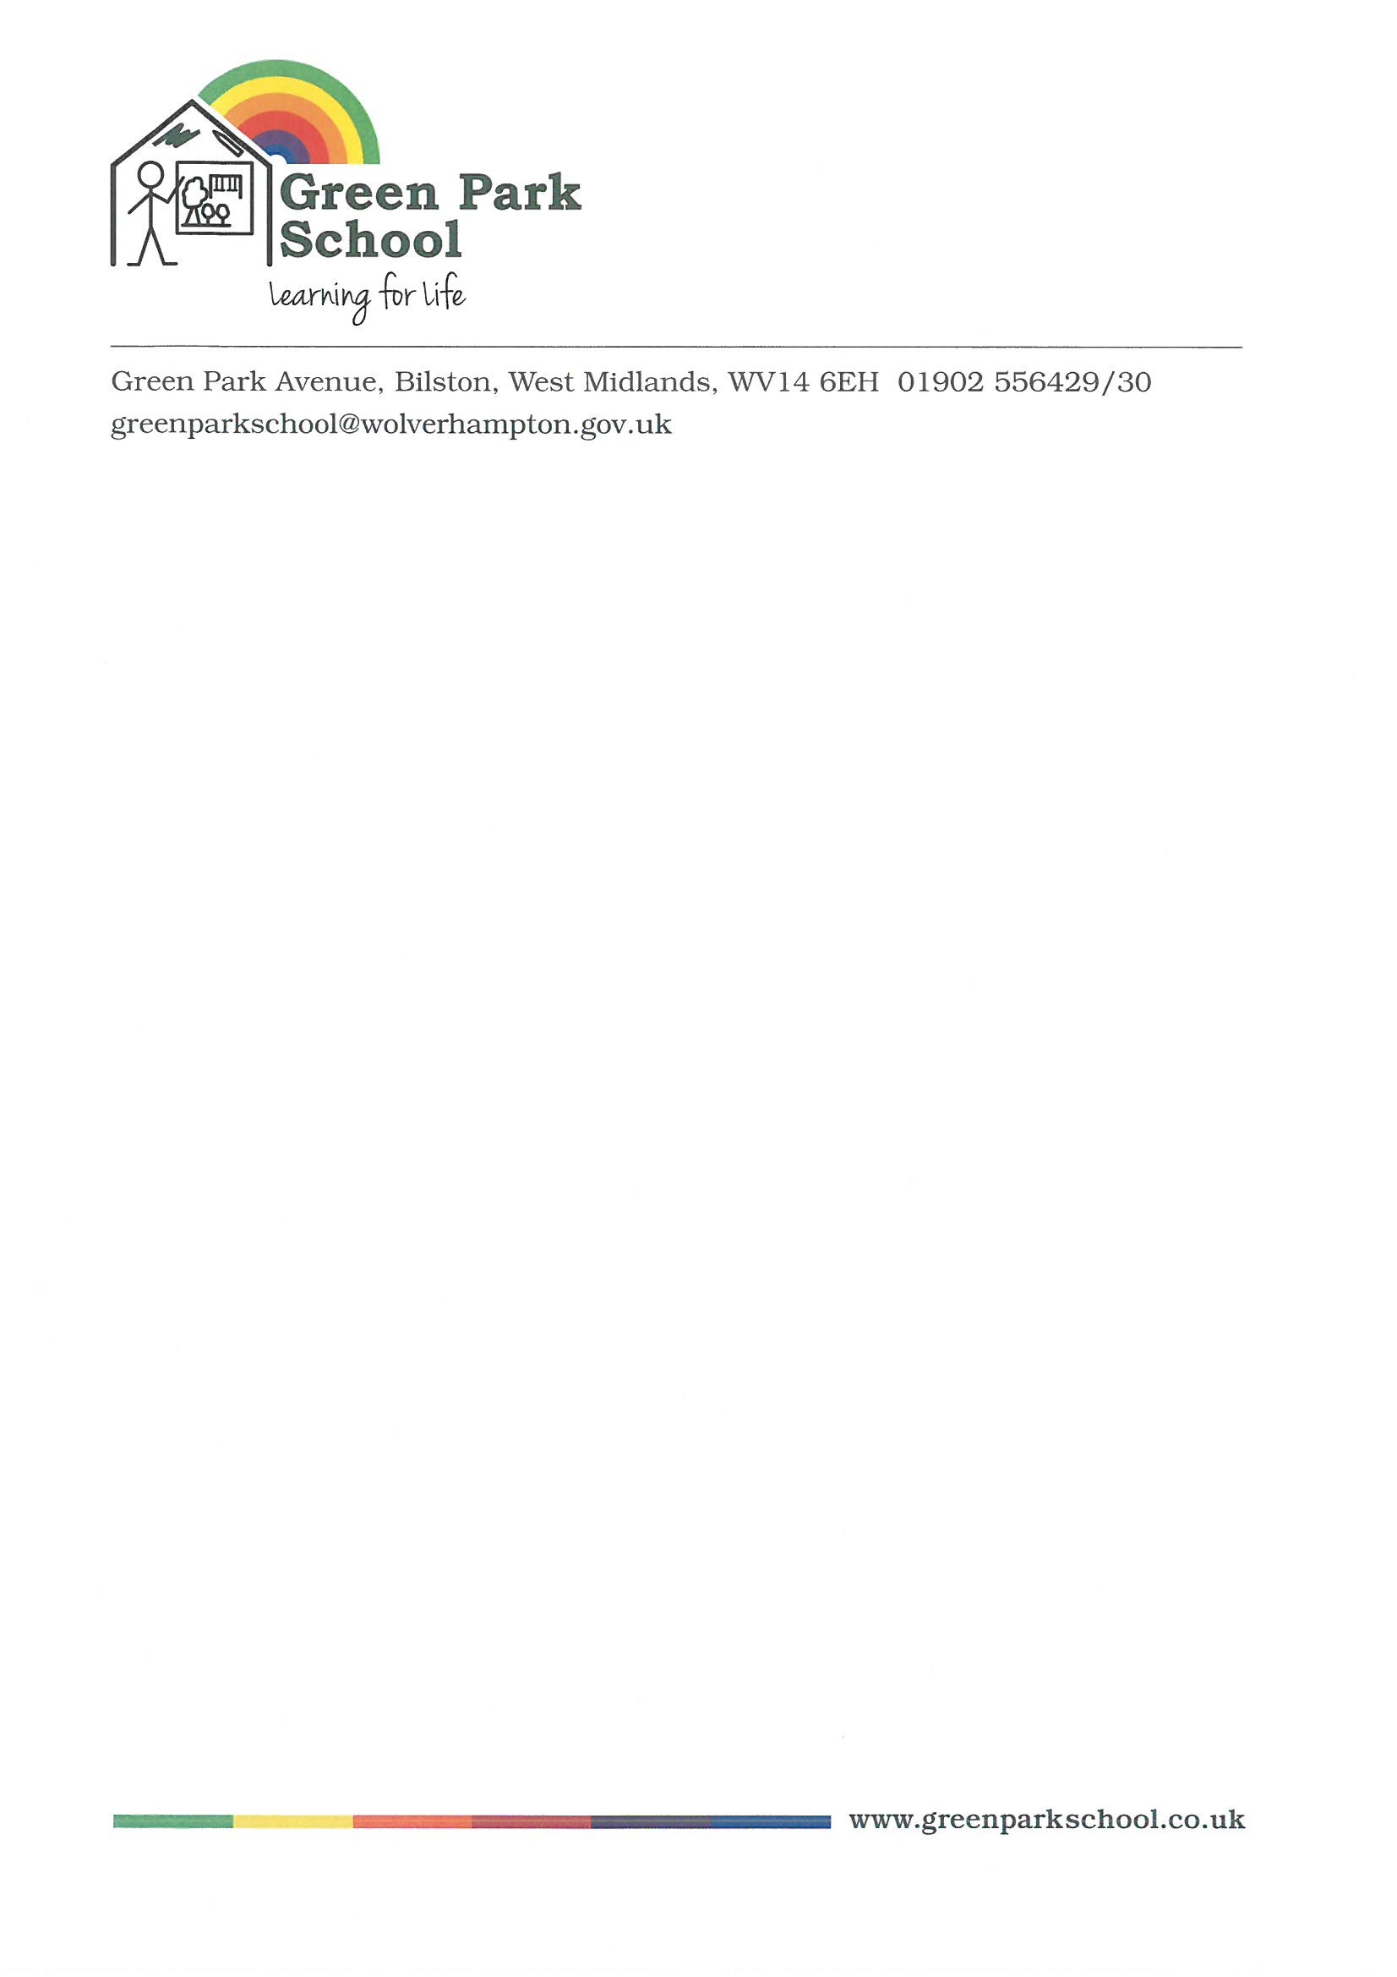

Friday, July 15, 2022

Dear Parents,

**Re: Updated Red Extreme Heat Warning**

The Met Office have reviewed the extreme weather situation for the next few days and have now issued a Red Extreme Heat Warning for next Monday and Tuesday.

We have received several queries about the possibility of school closures due to the extreme heat. We will **remain open** but given the escalation of the warning; we will give parents the option to keep their children at home on Monday & Tuesday and the absence will be authorised. If you do intend to keep your child at home please email: [greenparkschool@wolverhampton.gov.uk](mailto:greenparkschool@wolverhampton.gov.uk) so that absence can be authorised.

For those children attending school next week, the advice remains the same as in the letter yesterday – loose comfortable clothing and you can send in extra drinks.

Many thanks for your continued support,

Kind regards,

*L Dawney*

**Lorraine Dawney**

Headteacher